CLI

Practice Drill 1

  - Create the following directory structure. (Create empty files where necessary)
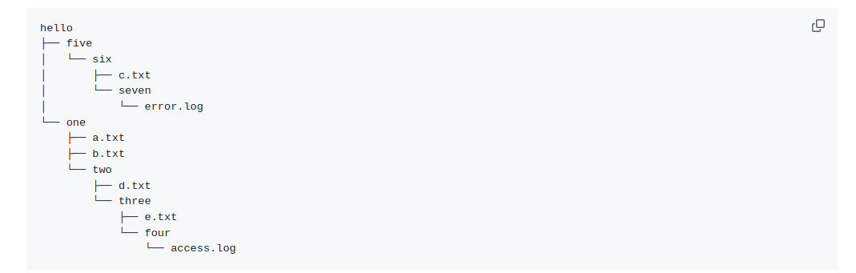
Steps -
  - mkdir hello
  - cd hello
  - mkdir five six
  - cd five
  - mkdir six
  - cd six
  - touch c.txt && mkdir seven
  - touch seven/error.log
  - cd ~/hello/one
  - touch a.txt b.txt && mkdir three
  - cd three
  - touch d.txt && mkdir three
  - cd three
  - touch e.txt && mkdir four
  - touch four/access.log
  - cd ~
  - tree hello

Explanation -{
cd : to navigate in the directories
cd ~ : home directory
mkdir : to create a directory
touch : to create a file
tree : give branched structure
}

Outcome -

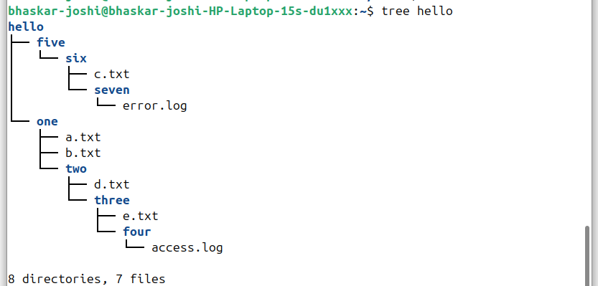
.

2) Delete all the files having the .log extension

Command - find . -name "*.log" -exec rm {} +
Explanation -
{
find . – means that it will search in the current directory and all subdirectories
-name “*.log” - -name flag is used to match a pattern which in this case is all files ending with .log
-exec rm {} + – execute flag is used here to perform a specific function which is remove. Also for the execute a batch is made under {} and which has been l ocked by + at the end so that after all the log files are found in the batch then only rm performs it’s action (so that rm doesn’t have to run again and again)
}
Result -
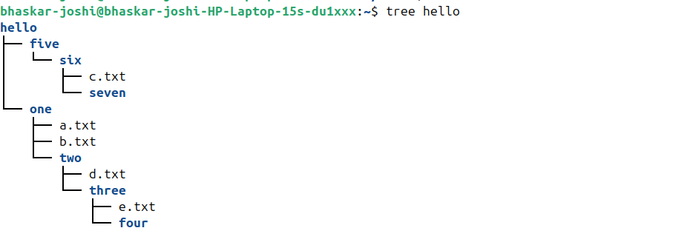
.

3) Add the following content to a.txt
‘Unix is a family of multitasking, multiuser computer operating systems that derive from the original AT&T Unix, development starting in the 1970s at the Bell Labs research center by Ken Thompson, Dennis Ritchie, and others’

Steps :
1. cd hello/one
2. cat > a.txt
Unix is a family of multitasking, multiuser computer operating systems that derive from the original AT&T Unix, development starting in the 1970s at the Bell Labs research center by Ken Thompson, Dennis Ritchie, and others
3. cat a.txt

Explanation -
cat : to view a file
cat > : to add text into the file

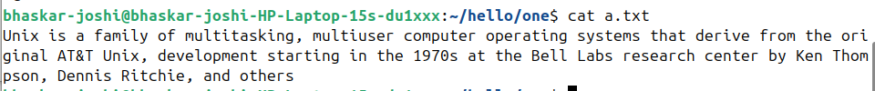
.

4) Delete the directory named five
Steps -
1. cd ..
2. rm -r five

5) Rename the one directory to uno
mv one uno

6)Move a.txt to the two directory
Step1 - cd uno
Step 2 -mv a.txt two/a.txt

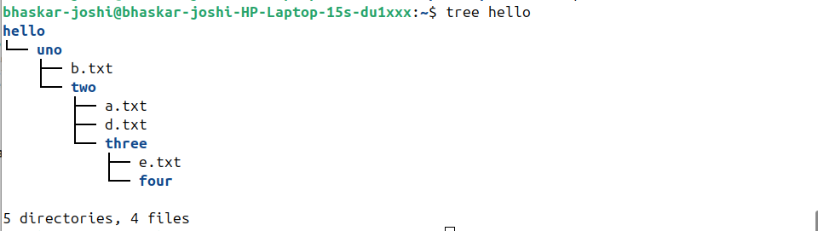
Final Tree -.

Practice Drill 2

Pipes
- Download the contents of "Harry Potter and the Goblet of fire" using the command line from here
Steps-
1. mkdir harryPotter
2. curl -o book.txt https://raw.githubusercontent.com/bobdeng/owlreader/master/ERead/assets/books/Harry%20Potter%20and%20the%20Goblet%20of%20Fire.txt
Explanation :
curl -o : curl or Client URL is used to transfer data and -o the transferred data into book.txt.

- Print the first three lines in the book
head -n 7 book.txt | tail -n 3
(head gives lines from starting and tail gives line for the end)
- Print the last 10 lines in the book
tail -n 10 book.txt
- How many times do the following words occur in the book?
  - Harry - grep -o 'Harry' book.txt | wc -l
  - Ron - grep -o 'Ron' book.txt | wc -l
  - Hermione - grep -o 'Hermione' book.txt | wc -l
  - Dumbledore - grep -o 'Dumbeldore' book.txt | wc -l
Single Command - grep -o -E "Harry|Ron|Hermione|Dumbledore" book.txt | s ort | uniq -c
(Explanation – grep: matches required text
-o: give match of only inputed text
-E: to match multiple values at one
sort : sort everything in alphabetic order
uniq-c: gives count of unique elements)

- Print lines from 100 through 200 in the book
head -n 200 book.txt | tail -n 101
or
awk ‘NR>99 && NR<201’ book.txt
(awk is used here to select row numbers from 100 to 200)
- How many unique words are present in the book?
tr -c '[:alnum:]' '\n' < book.txt | sort | uniq -c | wc -l
(Explanation-
tr -c ‘[:alnum]’ ‘\n’) <book.txt : tr or translate here is used to manipulate the text. So, first of all book.txt is inputed in tr and -c (complementary) flag takes two argments(i this case [:alnum:] and \n ), so -c leaves all the first arguments and except them converts all the other things into a new line so that every word is seperated into a new line
sort | uniq -c | wc -l : now words in every line are sorted so same words come together, then there count is done and at last a sum of all is output by wc.

Processes, ports

- List your browser's process ids (pid) and parent process ids(ppid)
ps -eo pid,ppid,comm | grep brave
Explanation-
ps: process status
-e: every processe
-o : output format which is pid(process id),ppid(parent process id),comm(command)
  - Stop the browser application from the command line
kill 9039 (pid taken from earlier step)
or
pkill -9 brave
- List the top 3 processes by CPU usage.
top -o %CPU | head -n 10
- List the top 3 processes by memory usage.
top -o %MEM | head -n 10
- Start a Python HTTP server on port 8000
python3 -m http.server 8000
- Open another tab. Stop the process you started in the previous step
Step 1 - ps aux | grep http.server
Step 2 – kill 26462
- Start a Python HTTP server on port 90
sudo python3 -m http.server 8000
- Display all active connections and the corresponding TCP / UDP ports.
netstat -tuln (t – tcp, u – udp, l -listening ports, n-numerical address)

- Find the pid of the process that is listening on port 5432
netstat -tuln | grep 5432

Managing software
Use apt (Ubuntu) or homebrew (Mac) to:
  - Install htop, vim and nginx
sudo apt install htop
sudo apt install vim
sudo apt install nginx

  - Uninstall nginx
sudo apt uninstall nginx

Explanation- sudo : grants admin permission ,apt : advanced package tool; to install new packages

Misc
- What's your local IP address?
ifconfig | grep inet | head -n 1 | awk '{print $2}'
(ifconfig – interface configuration to look for all networks )
- Find the IP address of google.com
nslookup google.com
(nslookup – to look for dns and ip)
or
host google.com
- How to check if Internet is working using CLI?
ping -c 4 8.8.8.8
(if it fails then network connection is not there)
- Where is the node command located? What about code?
whereis node && whereis code

